**Web Browser**



1. Find information (Print screen)
   1. Find top 8 Web Browser
2. Google Chrome.
3. Mozilla Firefox.
4. Microsoft Edge.
5. Opera.
6. Vivaldi.
7. Torch.
8. Brave.
9. Maxthon Cloud.
   1. Find top 8 logos of Web Browser

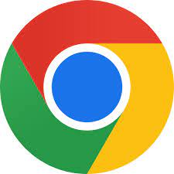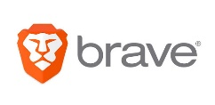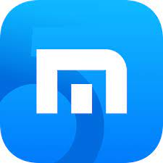

* 1. Find shortcut key 10 on Chrome
  + Open new tab: CTRL + T
  + Close the tab: CTRL + W
  + Reopen closed tab: CTRL + SHIFT + T
  + Reload: F5
  + View history: CTRL + H
  + View Download: CTRL + J
  + Find Word: CTRL + F
  + Display the current website in full-screen mode: F11
  + Close Browser: CTRL+ SHIFT + Q
  + Show or hide the Bookmarks: CTRL + SHIFT+ B
  + Open the Bookmarks Manager: CTRL + SHIFT + O

1. Bookmarks Bar (print screen)
   1. Synchronize your account with Chrome

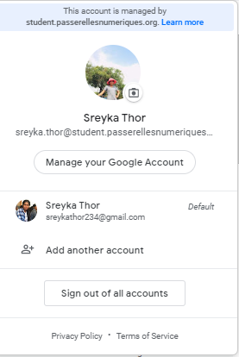

* 1. Enable bookmarks bar



* 1. Create Folder your name and partner (example: sreyvan-sokna)



* 1. Search website and save address bar to bookmarks bar your name
     + <https://timetables2.pnc.passerellesnumeriques.org/>
     + <https://www.passerellesnumeriques.org/en/>